Weighted Sock or Stocking
Items needed:  - Long, thick sock or stocking  - Rice, plastic pellets, beans or sand  - Fishing line  - Scissors  - Needle (mine is beading needle  - Small ziplock sandwich bags | 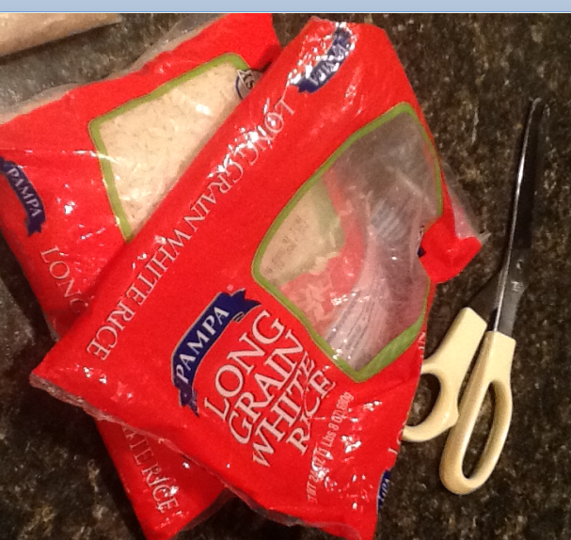
1. Place rice into small Ziploc bags | 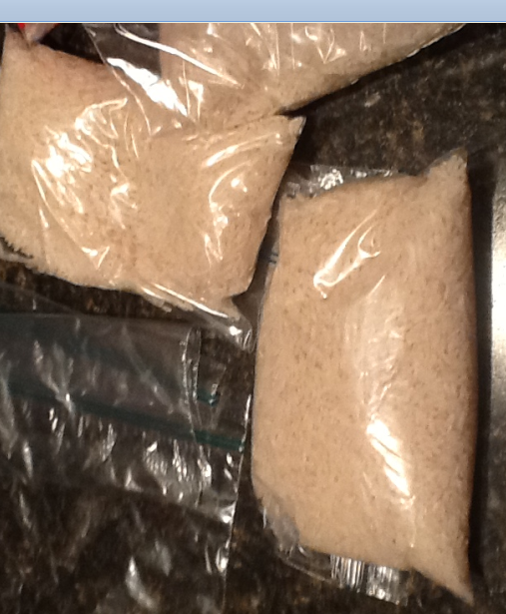
2. Place rice bags into sock or stocking to fill | 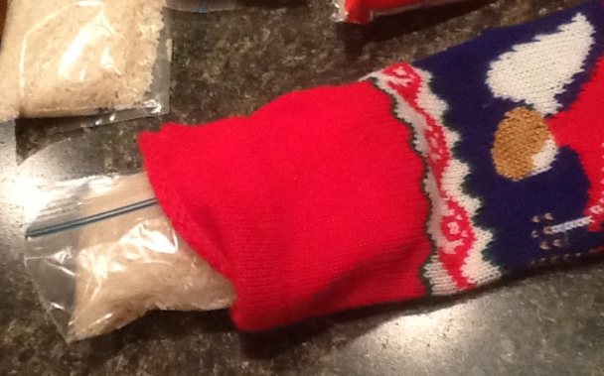
3. Place piece of fishing line into needle (mine is a beading needle) | 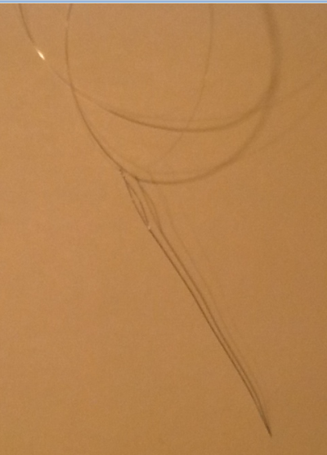
4. Sew end of sock or stocking shut | 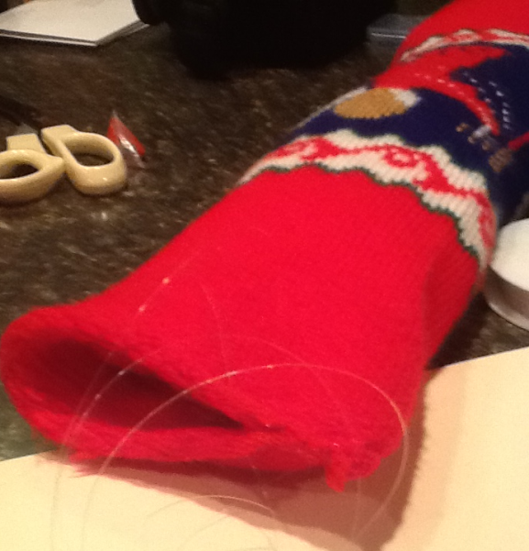
5. Now you have a weighted stocking | 