1. Get a pillow case and cut it in half horizontally
2. Measure width of pillow case and divide into 6 equal parts
3. Stitch zigzag on each area marked length wise
4. Place items into each pocket (plastic pellets, sand, rice)
5. Stitch zigzag to close the pockets
6. Stitch zigzag for second closure
7. You can place another pillowcase over the pad as a cover if you would like
Weighted Lap Pad

** In the picture, there are too many pockets**
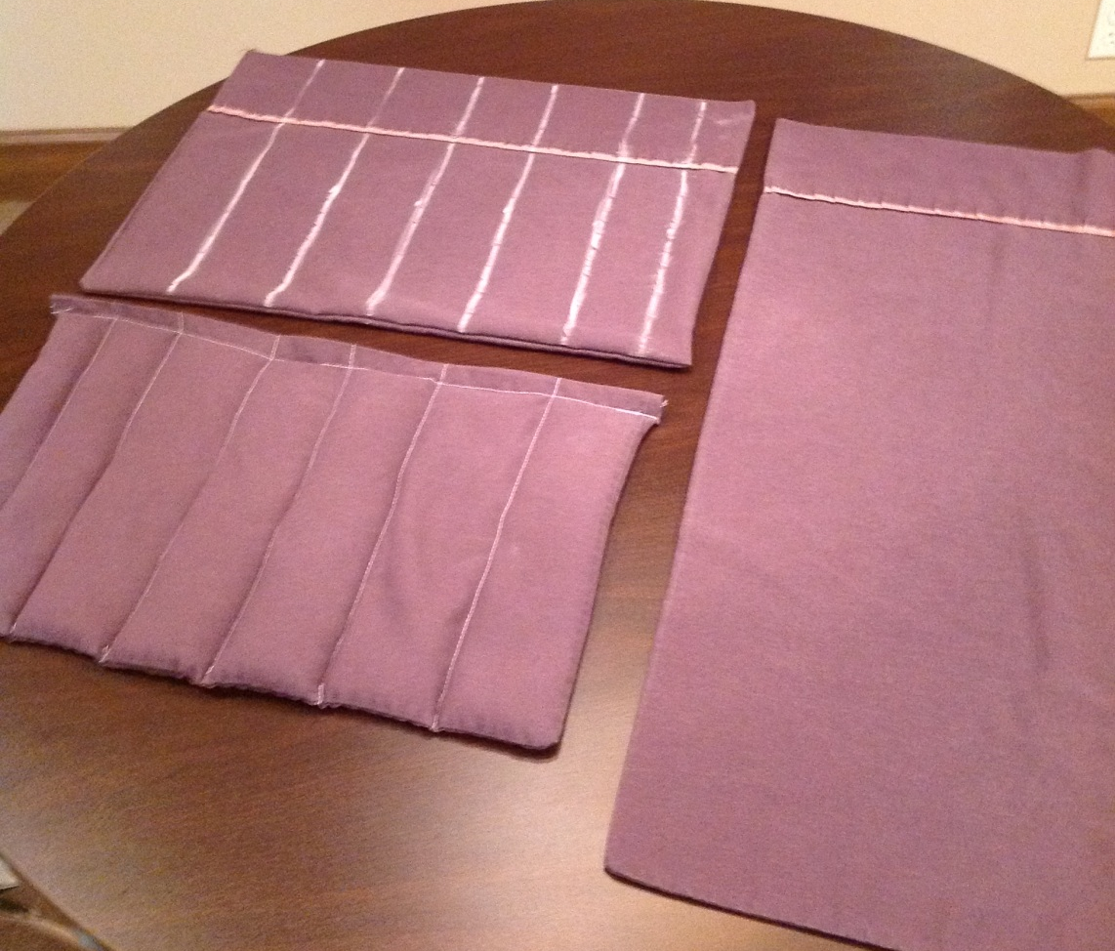
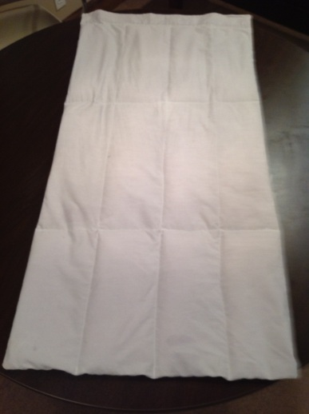
This was a king size version.

