Tactile Schedule
1. Number the events of the day (you  could use jewels to create braille numbers) on a piece of posterboard or construction paper | 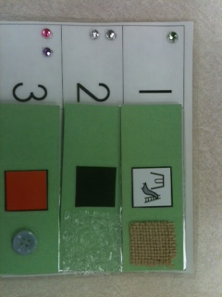
2. Use various high contrast textures for each event or class (make 2 sets) | 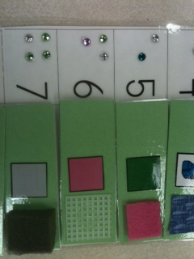
3. Place the textures onto cardstock with words
4. Laminate the cardstock and put on Velcro
5. Place the second set of texture cards at the locations the student goes to | 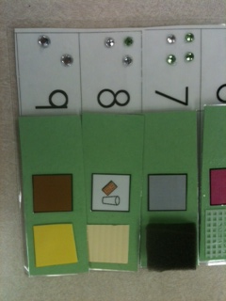
6. Have the student take the texture card and match it to the texture card at the location | 