Swiffer Hair Brush Extender
Items needed:  - Regular length Swiffer duster  - Brush with handle that has a flattened area (I used the Wetbrush)  - Industrial strength Velcro | 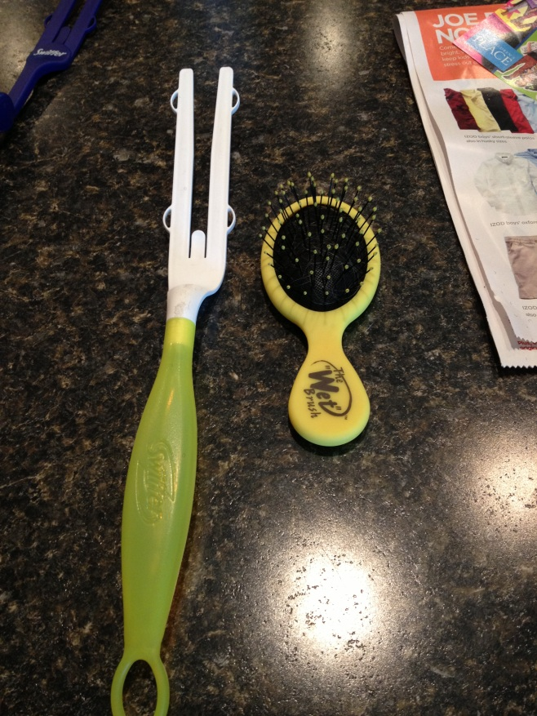
1. Place soft side of Velcro onto tines of Swiffer duster | 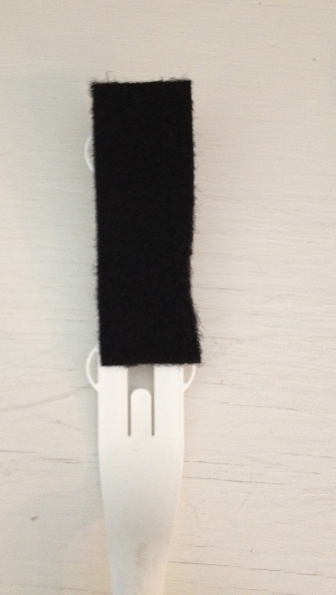
2. Place hard side of Velcro onto back of hair brush handle | 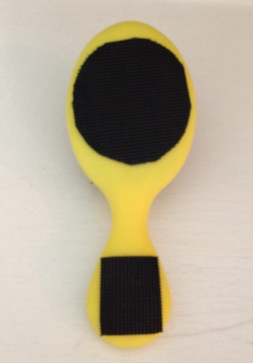
3. Velcro brush to Swiffer | 