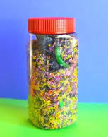 Dry
Rice
Sand
Salt
Sugar
Macaroni
Beads
Marbles
Bean Bag filler with Salt

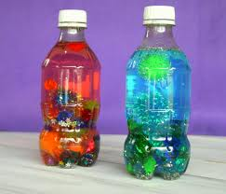 Liquid
Water
Oil
Oil & Water
Karo Syrup
Bubbles
Hair Gel
Shampoo
Liquid Laundry Detergent
Aqua Beads

