Ribbon Fidgets
Items needed:
- 3 Fabric pieces approximately 4” long (fleece was used)
- Pony beads (20)
- 1 piece of 12-14” ( 1/8”) ribbon to put beads on
- 3 pieces of 12-14” (5/8”) ribbon
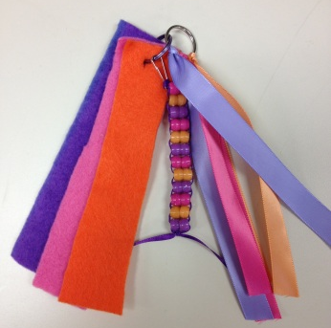
- 2 key chain rings
- 1 lanyard hook
- 1 carbiner clip

1. Cut hole into the 3 fabric pieces at the top and place them on key chain ring

2. Tie 3 pieces of 5/8” ribbon to key chain ring

3. Put ribbon onto lanyard hook

4. Put 2 beads on one side of ribbon and place second piece of ribbon through the two beads

5. Repeat the pattern and tie off the end of ribbon

6. Hook 2 key chain hooks together and hook on lanyard hook

7. Place one key chain clip onto carbiner clip to hook to belt loop

