My Job at School

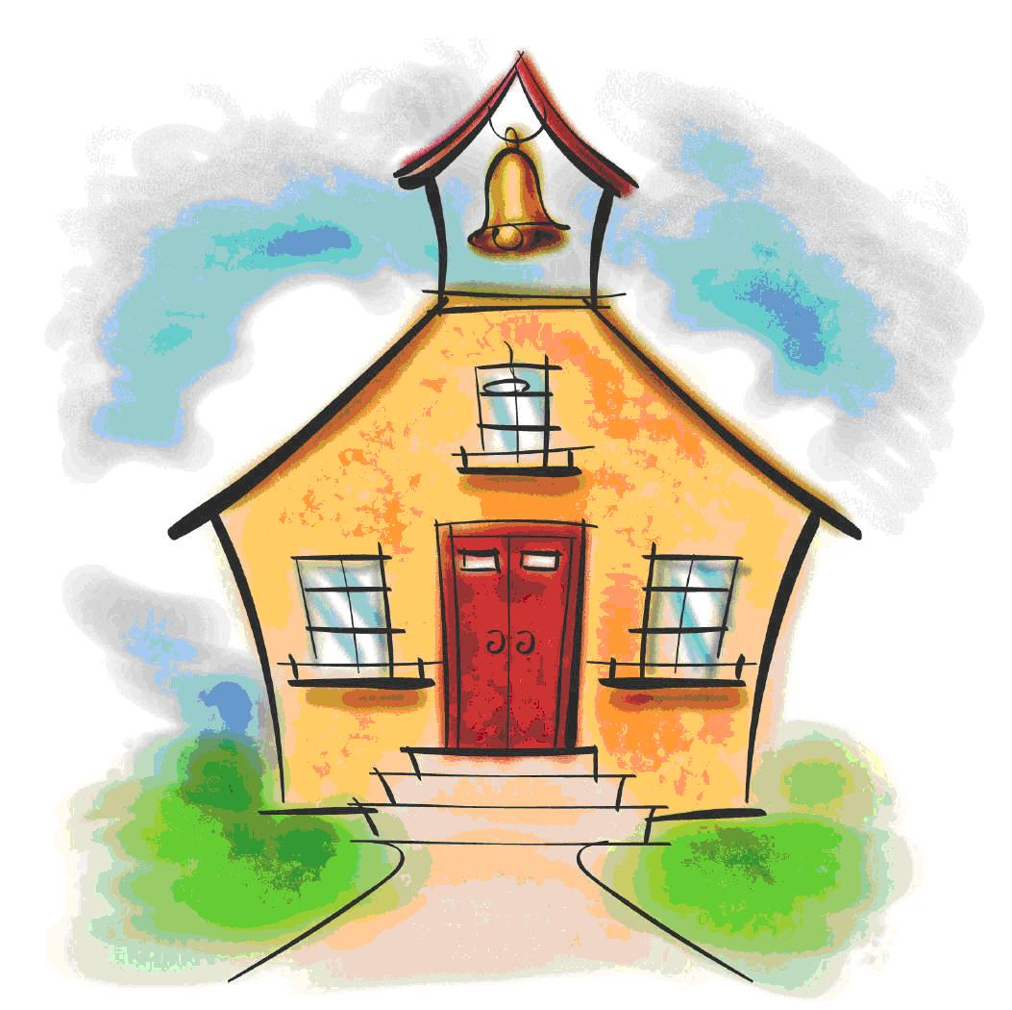

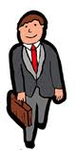

Would you believe I already have a job?

I work at a school named . My job title is a student.

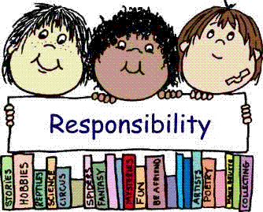

For my job, I have certain “responsibilities”. That means things I have to do.

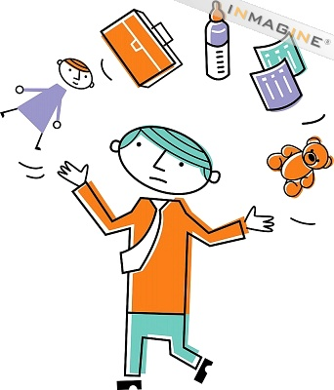

Adults have responsibilities too. They have to take care of their children and pay for their home.
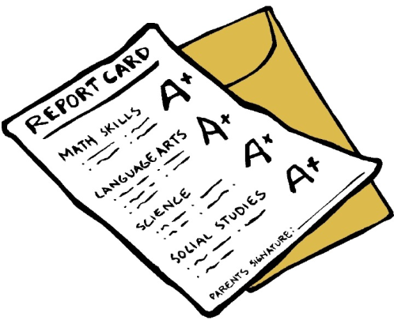

My responsibilities are part of my job at school. I get paid at my job when I get my report card and .

If I get good grades, that means I am doing my job.

Here are my responsibilities for my job at school:
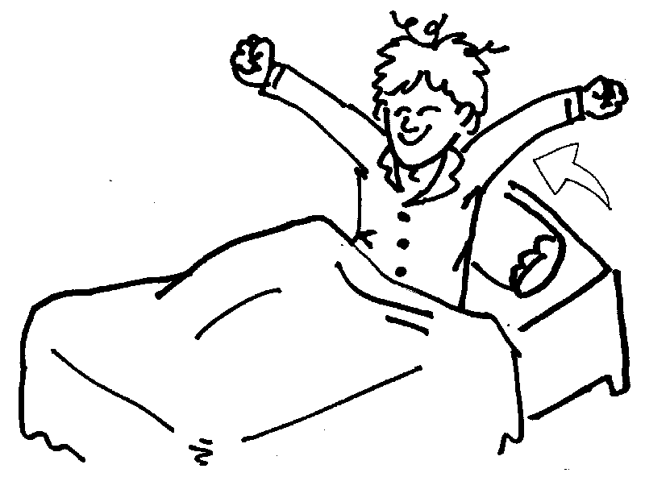 | 1) Get out of bed on time
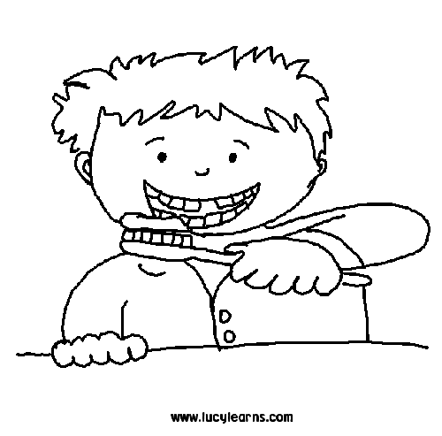 | 2) Get ready for school
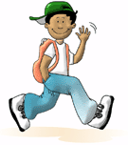 | 3) Walk to my classroom
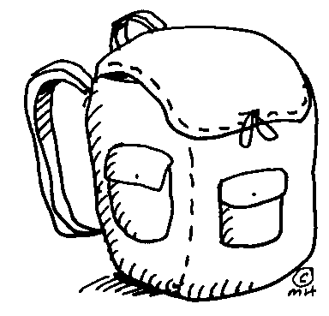 | 4) Unpack my backpack
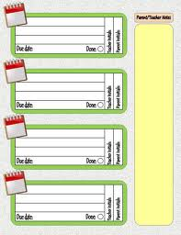 | 5) Write in my agenda book
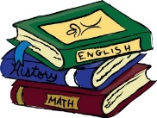 | 6) Pack my backpack with homework
 | 7) At home, empty my backpack
 | 8) Ask mom or dad to sign agenda
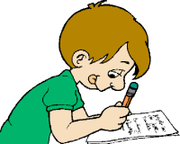 | 9) Do my homework before the timer ends

’s Morning Routine
Did I………

1) Walk to class by myself
2) Unpack backpack
3) Give teacher agenda and papers

’s Afternoon Routine
Did I……..

 |  | 1) Write homework in agenda
 |  | 2) Get backpack and coat from locker
 | 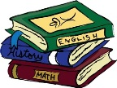 | 3) Put homework in backpack

Homework Routine

 |  | 1) Did I unpack backpack
 |  | 2) Did mom or dad sign agenda book
 |  | 3) Did I do my homework before timer ended
 | 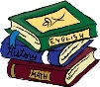  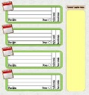 | 4) Did I put homework and agenda in backpack

