Make it Take it: iPad stand
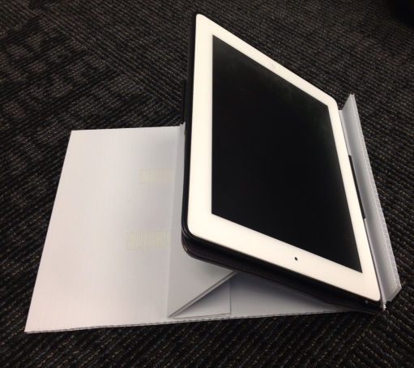

Supplies:
*cardboard or plastic corrugated yard signs (a 18 x 24 sign would make two stands)
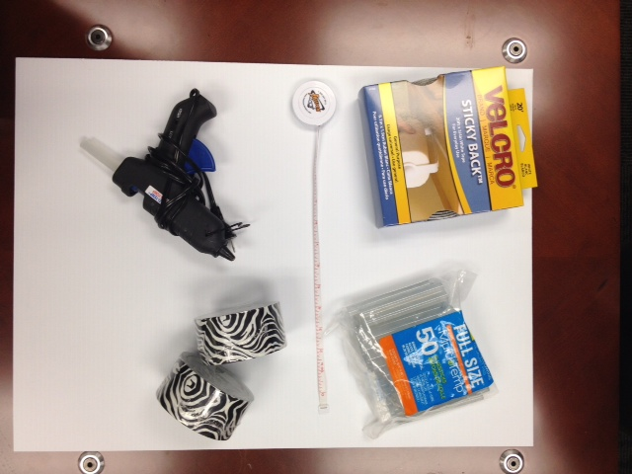
*glue gun
*Velcro (3/4” wide) 11 inches of rough & 8 ½ inches of soft
*Non-slip shelf liner (8 x 11” piece & 8 x 4” piece)
*Box cutter
*Corner guard (9” piece)
*Tape measure
*double sided tape – about 1” wide and will need about 17”.
*Decorative Duct Tape (optional)

To Create a Stand:
- Cut two 12 x 9” rectangles out of the cardboard or yard sign. MAKE SURE TO CUT AGAINST THE GRAIN
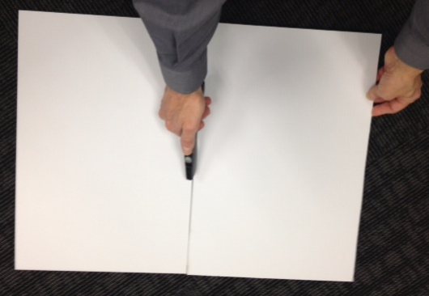
(When cutting against the grain, do not cut in the same direction as the lines. See picture on right.)

- Use a pencil to label a side A and side B of one rectangle.
A
- Score a straight line on side A of one of the 12x9 rectangles (against the grain) 1 ½ inches from the bottom.
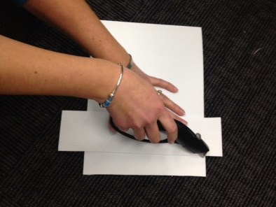

- Flip the same rectangle over to look at side B.
BA
- Score a straight-line in the middle (approximately) 6 inches on side B.

- Score another straight line at 2 inches on side B. Make sure that it is at the opposite end of the score on side A.
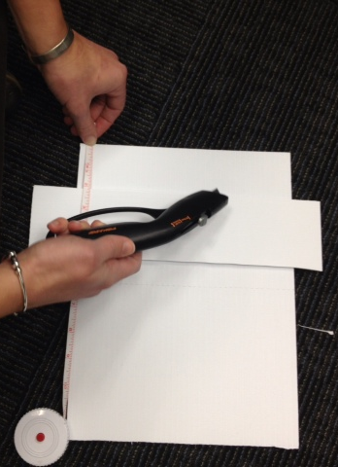

- On side A, fold the scored line down.
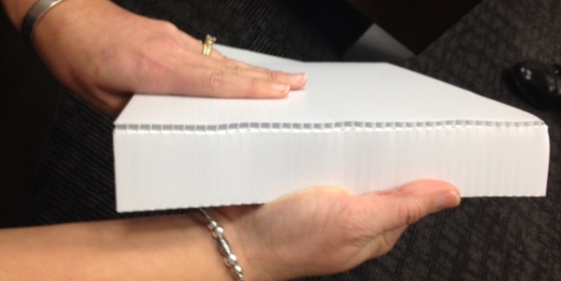
- On side b, fold the middle and last scored line down.
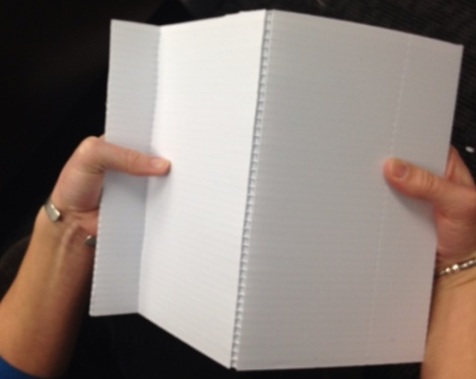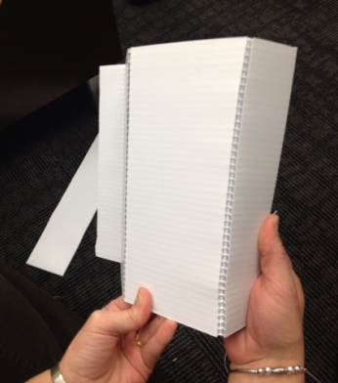

- Note: If you are going to decortate your stand with colored Duct tape, you will need to add it prior to the next step.

- Cut an 8 ½ inch strip of soft sticky back Velcro.

- On side B, attach the Velcro strip to the section B1.
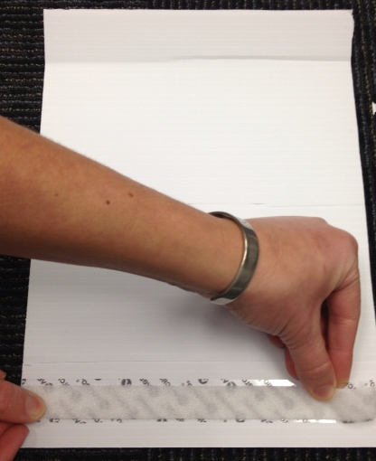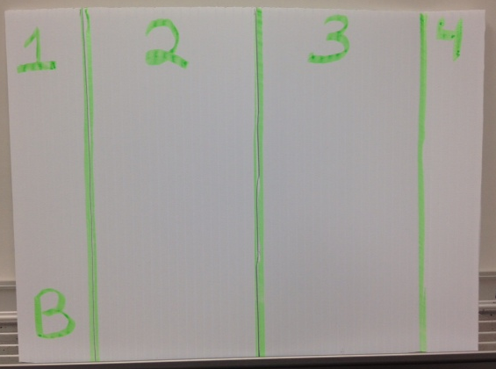

- Cut a piece of shelf liner about ½ inch smaller than the size of section B3.
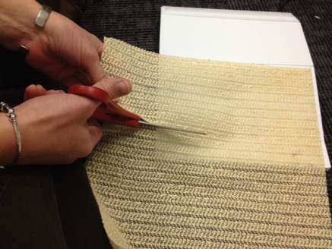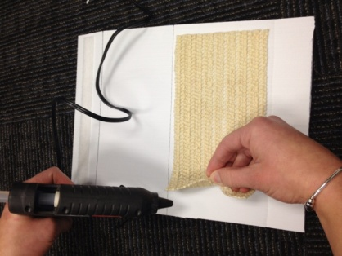

- Attach shelf liner to section B3 with hot glue or double side tape.
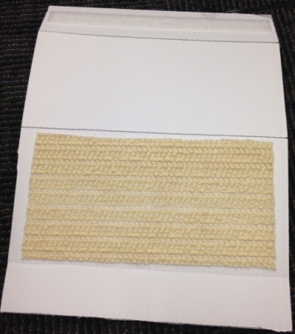
To Create a Base:
- Take the second 12 x 9 rectangle. Label one side C and one side D.
- Note: If you are going to decorate the base with Duct tape, you will need to do so prior to the next step.
- Add an 8 ½ inch piece of double sided tape to one end of side C. Do not peel of back of tape yet.
- Cut two strips of 5 ½ inches of the rough side of Velcro.
- From the tape on the base, measure in 1 ½ inches. This will be the top of the Velcro strips. The two strips will be about two inches apart parallel to each other.
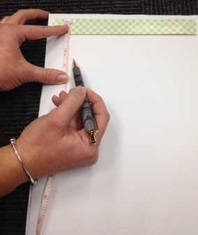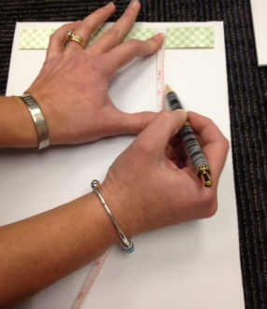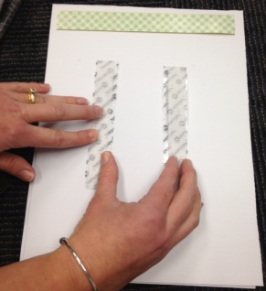
- Peel the paper of off the Velcro and stick down.
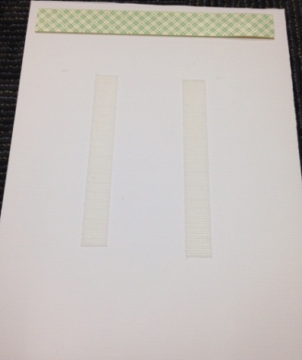
- Turn base over to side D.
- Cut shelf liner about ½ inch smaller than the rectangle.
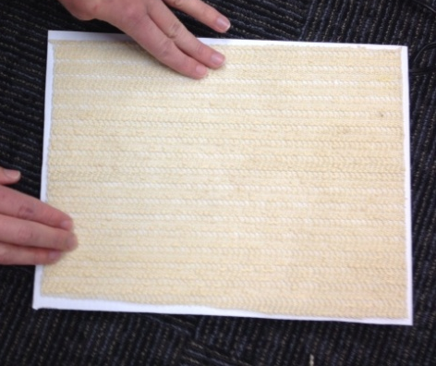
- Attach shelf liner to side D. You can use double sided tape, glue gun, or glue.

Attaching the stand with the base:
- Peel the back of the tape off.
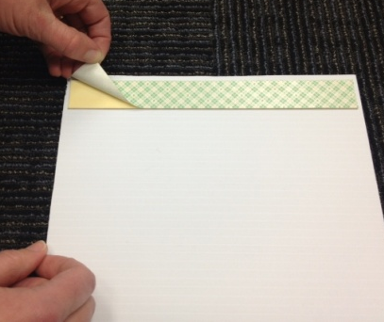
- With side B up, align section 4 to the edge of the base. Press together on tape.
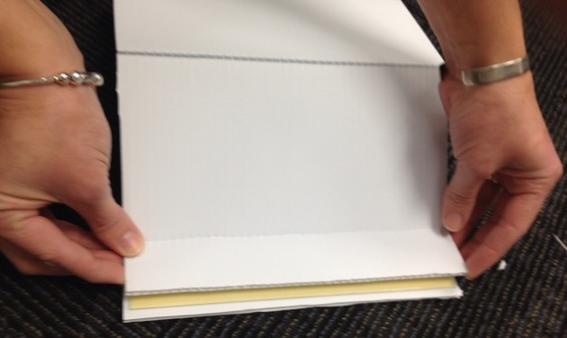
- Apply corner guard to B4. (This could be store bought or handmade support.)
- Attach the back at the angle that is needed.
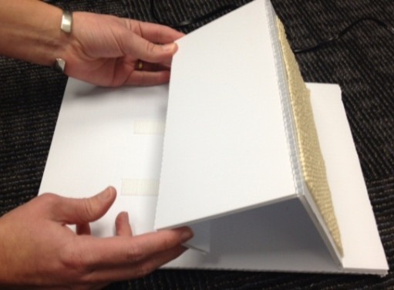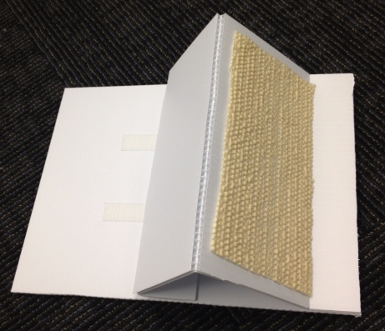

How to make Corner guard:

1. Measure piece of plastic 9 inches by 2 ½ inches.
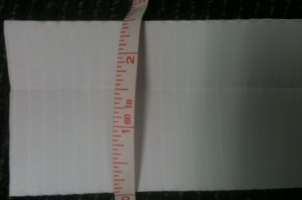
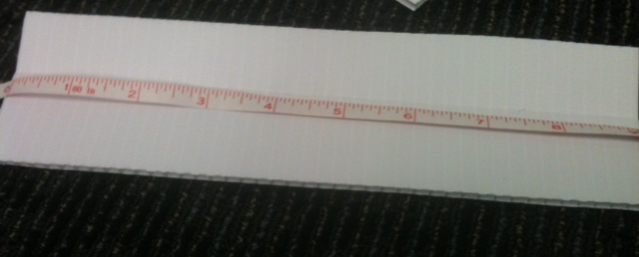

2. Score the plastic at 1 inch in.
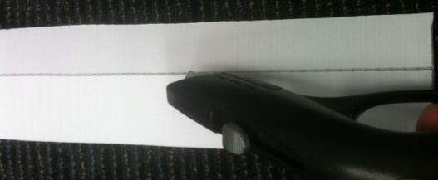

3. Bend piece at the score line.
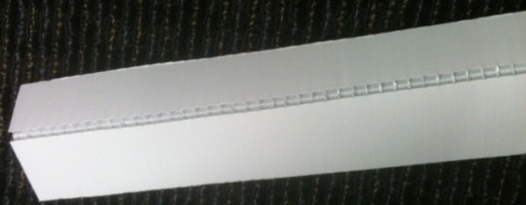

4. Add duct tape at bent area to help hold in bent position.

