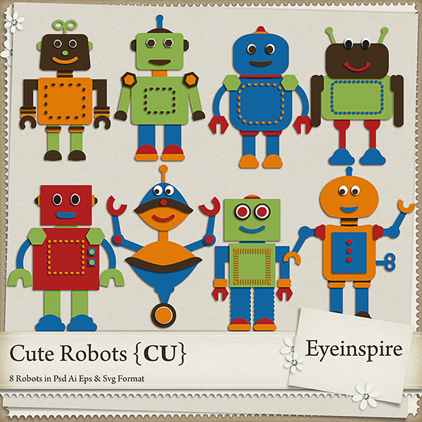  How to be a Friend! | My name is .

I go to Elementary. | I have two teachers, Mrs.  And Mrs. .

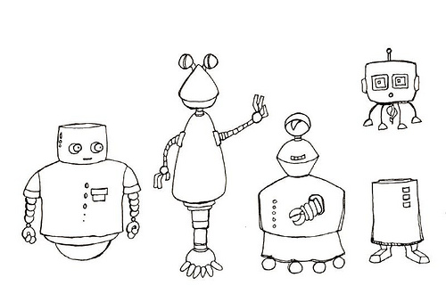  I have friends in both classrooms. | 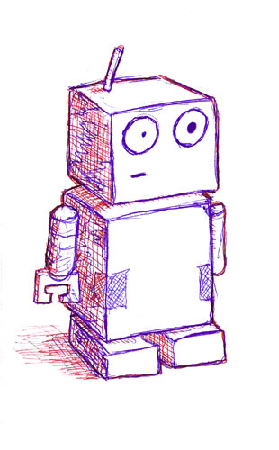  How do you treat your friends?

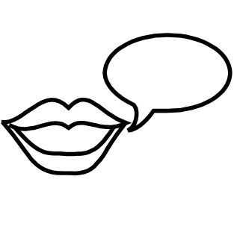  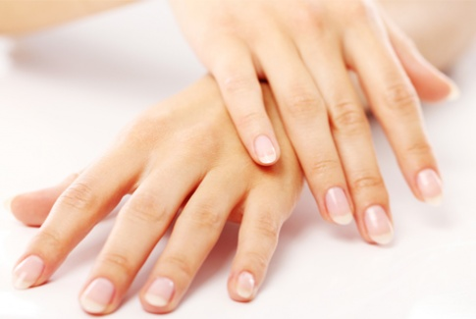  1. Use nice words and a  Quiet voice  2. Use nice hands and  feet  (no hitting or kicking) | Sometimes my friends make  me angry.

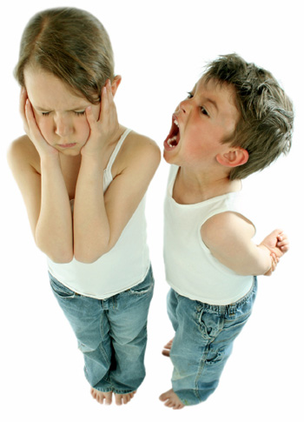  They may say mean words  Or bump and push me. | 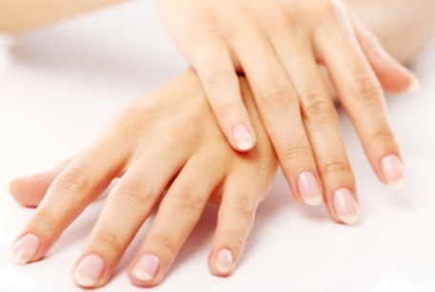  I have to follow the rules.  Nice words and nice hands  And feet

When I feel angry, I can….. | 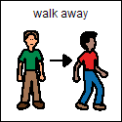  1. Get away from the person who is making me mad.

2. Tell teachers that I feel angry. My voice can be upset, but I need to use nice words. | 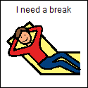  3. Ask to take a five minute break.

4. I might squeeze a stress ball | 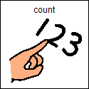  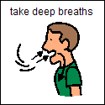  5. Count to five and take five deep breaths and then blow them out.

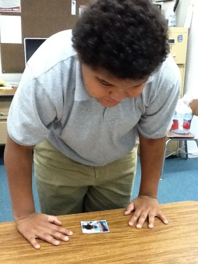  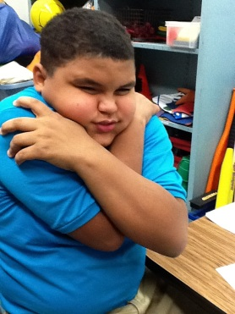  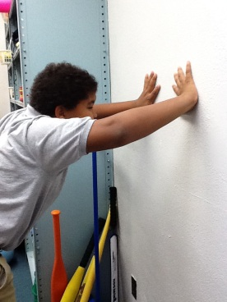  6. I can do exercises that make me feel better. | 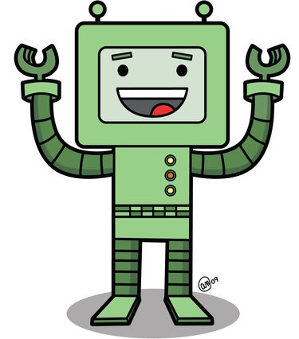  If I remember to do some of the 5 things when I feel angry, I can start to feel better and not so angry.

To be a good friend, I need  To use nice words and  Nice hands. | I will feel happy and  My friends will feel happy.

