Homemade Rolling Pin
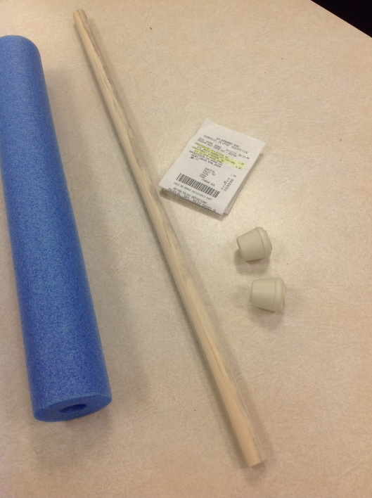

Items needed:
- 3/4” dowel rod
- 3/4” white rubber leg tips
- Pool noodle
Instructions:
1. Cut the dowel rod with saw to 2-2 ½ feet long
2. Cut pool noodle to slightly allow for 5” of dowel to stick out from each end
3. Put noodle on rod and place on rubber tips
4. Roll away!

